

|  |
| --- |
| [Version 1.1]  **Last saved by:** Ben McGregor  **Last saved on:** 31/03/2015 |

|  |
| --- |
| Iteration 4 Plan |
| 10/11/2014 |
| **Charlotte Hutchinson**  CO600: JustHealth Supervisor: Yang He |

Contents

1.0 Aims: 2

2.0 Requirements: 2

2.1 Functional requirements: 2

2.2 Non-functional requirements: 2

2.3 Domain Requirements: 2

3.0 Design 3

3.1 Search for patient and carer 3

3.3 Database design update 0

4.0 Use case: 0

5.0 Forgotten password change 1

6.0 HTTPS 1

7.0 Testing 1

JustHealth Iteration 4 Plan

# Aims:

* To have the ability for a carer and patient to be able to search for each other on both android and web
* To have the ability for a carer and patient to be able to connect to each other
* To make sure the connection is secure and completed in an effective way
* To ensure the POST requests are secure and authenticated.
* To have a profile page for both android and web
* Implement HTTPS
* Changed the way out API tests run

# Requirements:

## 2.1 Functional requirements:

1. The ability for a carer to be able to search for a patient- Web
2. The ability for a carer to be able to search for a patient- Android
3. The ability for a patient to be able to search for a carer- Web
4. The ability for a patient to be able to search for a carer- Android
5. The ability for a patient and carer to ‘connect’- Android
6. The ability for a patient and carer to ‘connect’- Web

## 2.2 Non-functional requirements:

1. User Documentation
2. Security
   1. To ensure POST requests are secure and authenticated
   2. To ensure patients and carers connect in a secure and safe way
3. Robustness
   1. Error handling
   2. Security (as above)
4. Ease of Use
   1. Simple and intuitive design
   2. Clear colour scheme

## 2.3 Domain Requirements:

1. Security (Android and Web)
   1. Make sure all POST requests are secure
   2. Ensure patients and carers connect in a safe and secure way. Authentication to ensure a person is who there profile says they are.

# Design

## websearchappsearch3.1 Search for patient and carer

## 3.3 Database design update

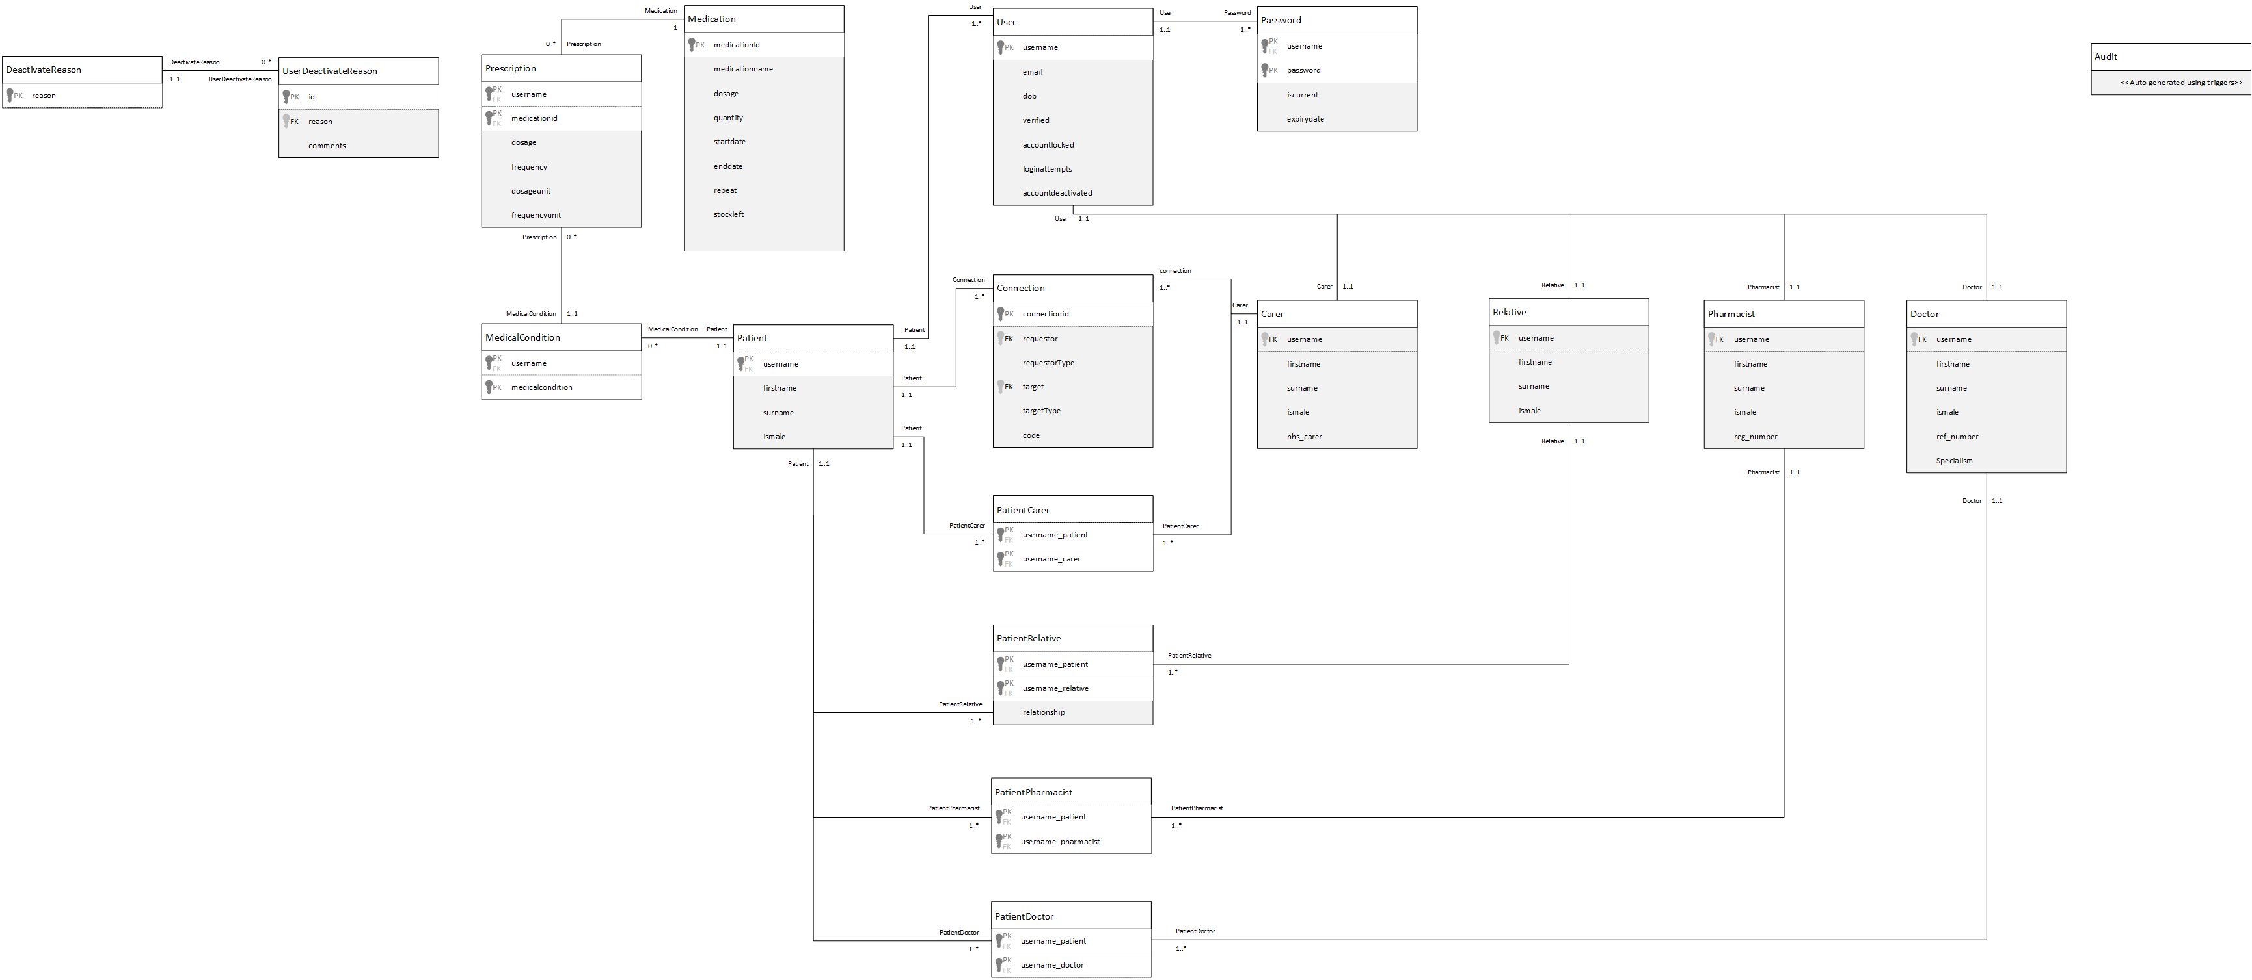Whilst planning the carer and patient connect function, we discovered we would need to add another table into the database. This is a separate table that would have the requestor and target as foreign keys and link from the patientcarer table. This new table would have the fields: requestor, requestor type, target, target type, code, connected. The reason we have decided to do this is because when we add more clients such as, doctor and pharmacist we would need to add their connection in also. Having another table will also mean less clutter and less impact on performance.

# C:\Users\benmcg92\AppData\Local\Microsoft\Windows\INetCache\Content.Word\2d3bffc8.png4.0 Use case:

User search & connect use case

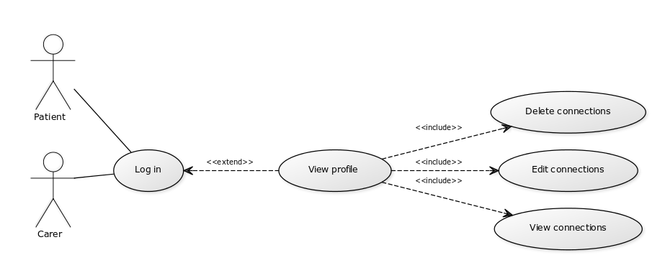

User sub-case

# 5.0 Forgotten password change

* We noticed a fault in our forgot password function, that you are able to change someone else’s password as long as you know their username and date of birth. Therefore in this iteration we have decided to change this.
* You are unable to reset the password by navigating directly to the reset password page
* In order to reset a password, because your account has been locked or you have forgotten your password, you are required to click the link in the email that you receive.
  + The link you receive in the email take you to the reset password page and automatically populates the username field.
  + The username field is set to read only which subsequently means that unless automatically populated it can not be changed which in turn prevents someone manually editing this field. Hence, a user has to have access to their email in order to change the password mitigating the risk of a threat actor trying to reset someone’s password.

# 6.0 HTTPS

* A server side change has meant that HTTPS has been implemented providing 128 bit TLS encryption.
* This will protect against people looking at the POST requests.
* This is not protected against man in the middle attacks.

# 7.0 Testing

We noticed that we had not tested the API themselves outside of the implementation of them in android and then web. Therefore, we are going to write individual tests for each API and run them separately. Tests also previously relied on others to ensure they pasts whereas now we are going to make them all individual.